Data preparation and sampling:-
We loaded our preprocessed dataset using pandas. We split our dataset into a 60/20/20 train, validation, and test split. Due to the large number of rows and columns in the dataset, it was impossible to do fine-tuning of llms. Hence, we decided to take a subset of the dataset. So we can test our pipeline and check if our training pipeline is working as expected.
Tokenizer:-
We have taken Microsoft/deverata-v3-base tokenizer. Tokenizer converts words into tokens, that then passed through the model and converted to meaningful numbers. These numbers are called embeddings.

Model Loading and freezing:-
We loaded the deverat-v3-base model for sequence classification. It is transformer based model. To focus on the sanity testing of our pipeline, we train the last layers, such as the classifier head and pool layers.

Training setup and Hyperparameters:-
We set up the training configuration. We trained only for 2 epochs due to hardware constraints and a batch size of 16 due to memory constraints. We also disabled FP16 training and added gradient clipping to prevent numerical instability. We initialized the Hugging Face Trainer with the model, training arguments, datasets, and a custom compute_metrics function. We then initiated the training process.
Evaluation and metrics:-
After training, we made predictions on the held-out test set. We calculated various metrics like F1-macro, F1-spam, AUC-ROC, and Average Precision, and generated plots like ROC curves, Precision-Recall curves.
Results:-

=============================================
TEST SET METRICS
=============================================
F1-macro : 0.5431
F1-spam : 0.3333
AUC-ROC : 0.7421
Avg Precision : 0.3478
Precision@1K : 0.1148
Precision@5K : 0.1148

precision recall f1-score support

Legitimate 0.96 0.62 0.75 108
Spam 0.21 0.79 0.33 14

accuracy 0.64 122
macro avg 0.58 0.70 0.54 122
weighted avg 0.87 0.64 0.70 122

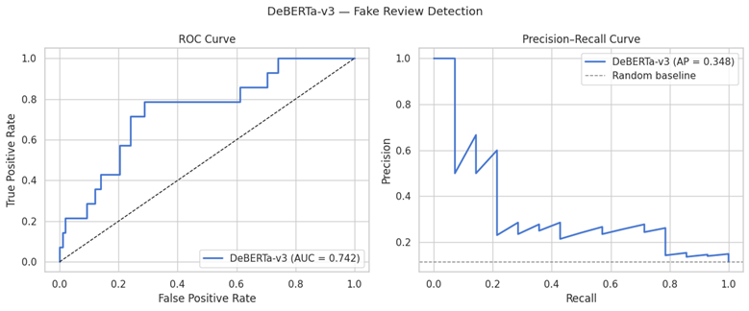ROC and precision recall curve

